**Camosun College**

**Electronics Department**

**ECET165 - LAB 1**

**INTRODUCTORY LABORATORY**

**The MPLAB Programming Environment**

**Reference:**

<http://www.microchip.com/mplab/mplab-x-ide>

<http://microchip.wikidot.com/mplabx:start>

**Objectives:**

Explore the MPLAB® X Integrated Development Environment (IDE) and write your first   
assembly language program.

**Procedure:**

**Install MPLAB X on your computer.**

**Note: Make an online logbook of all that you learn. Always log any errors.**

**Complete the questions near the end of tutorial and upload to D2L.**

**Part1 (if you are using a Lab computer go to part2):**

1. Install MPLAB X from the following link:

<https://www.microchip.com/en-us/development-tools-tools-and-software/mplab-x-ide>

1. Carefully follow the screen shots below to install the software: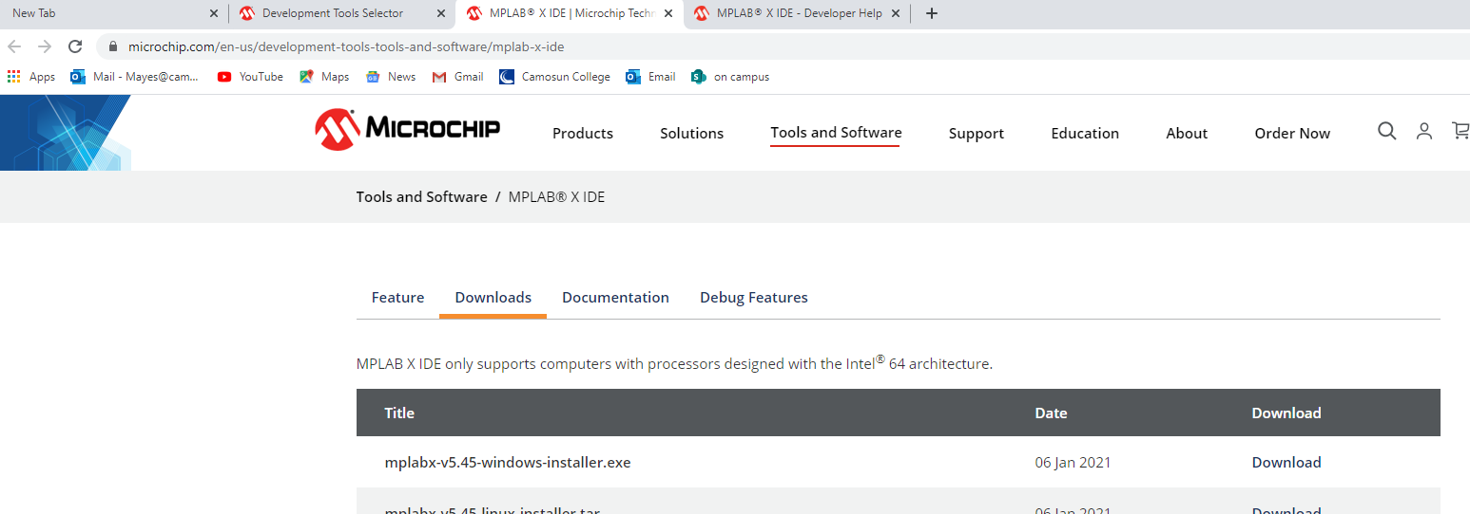

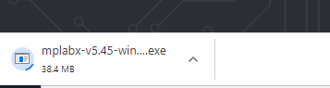

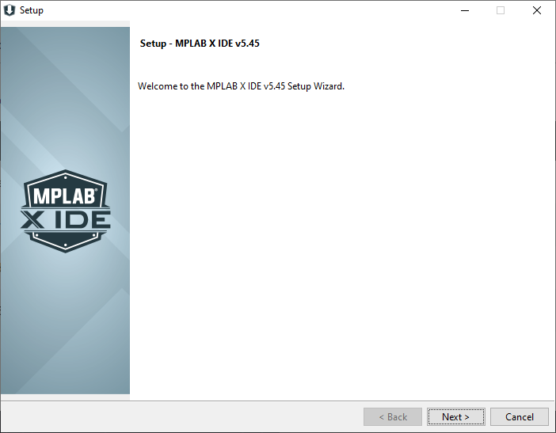

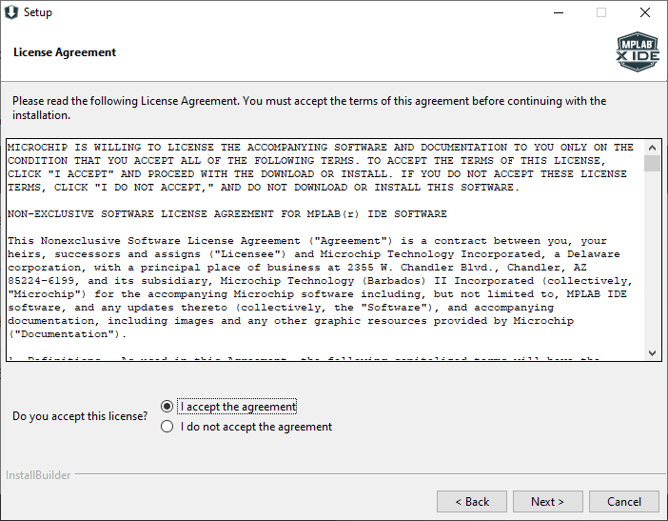

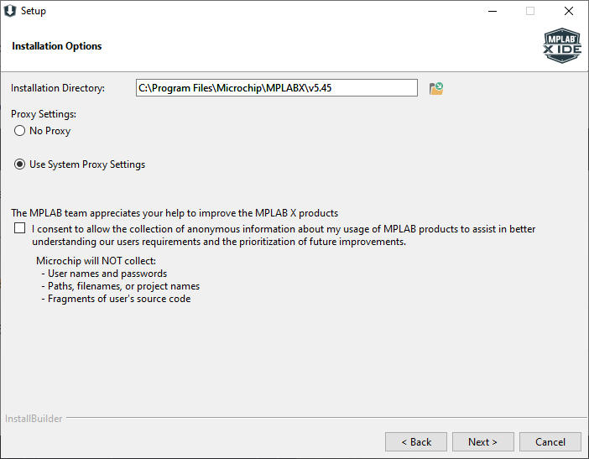

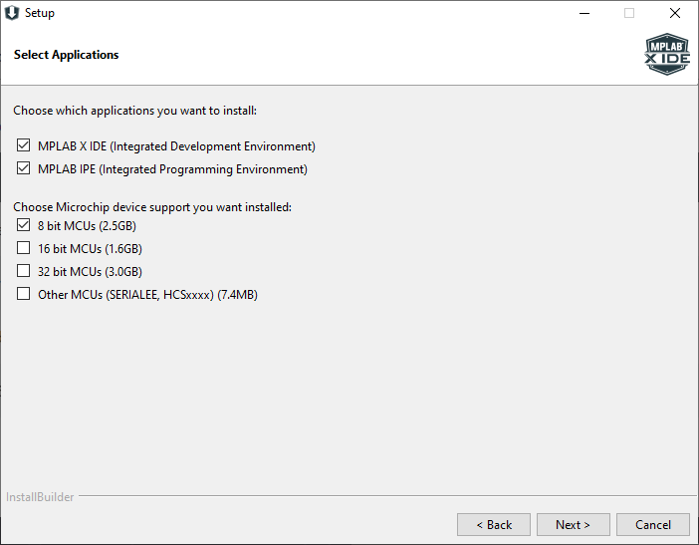

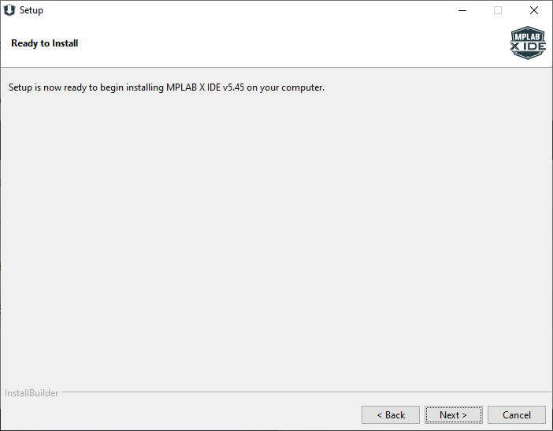

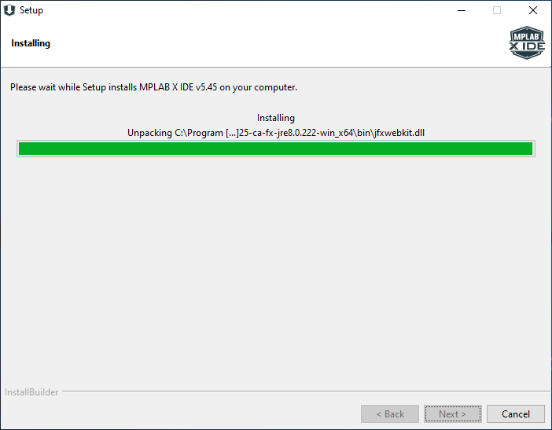

1. Now install the XC8 compiler: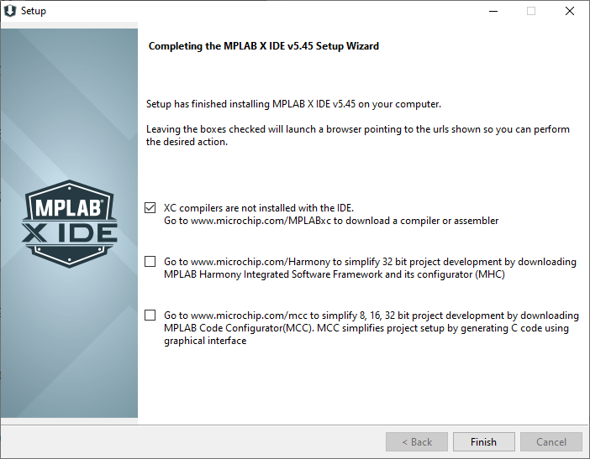
2. The following link should open when you click Finish:

<https://www.microchip.com/en-us/development-tools-tools-and-software/mplab-xc-compilers>

This is the version on the lab computers:

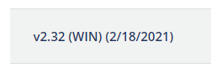

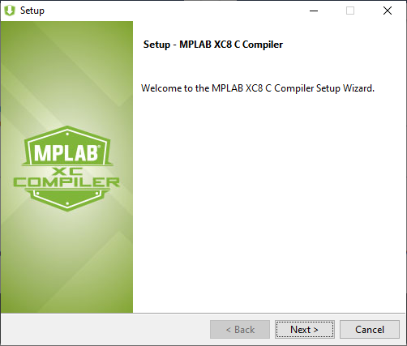

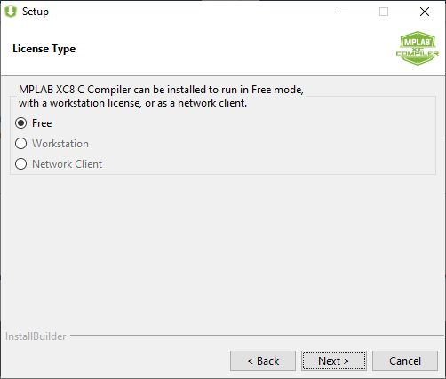

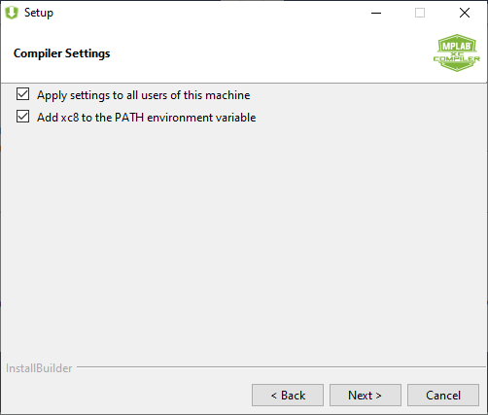

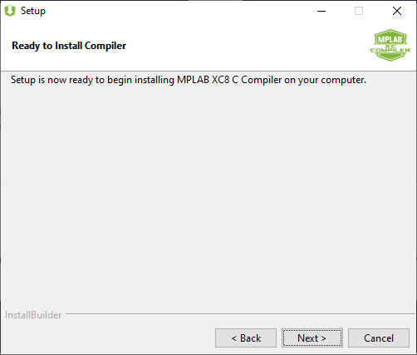

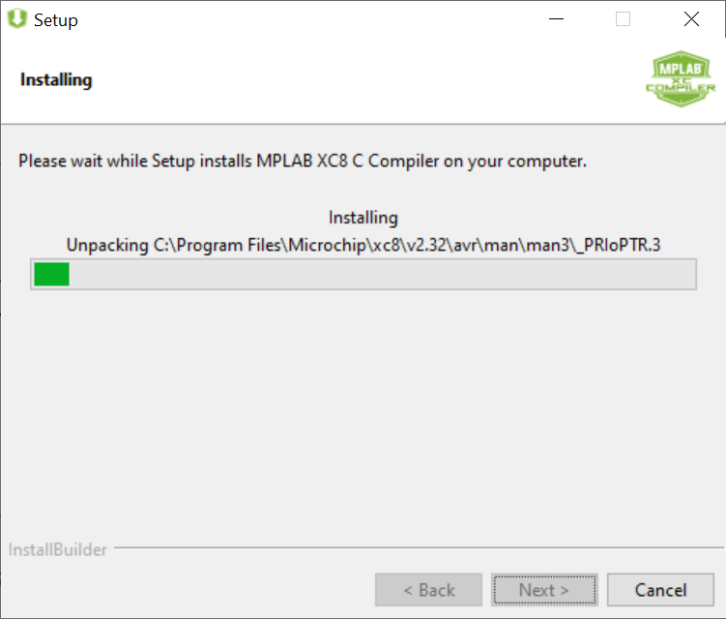

1. Click Next to install the free MPLAB XC8 compiler: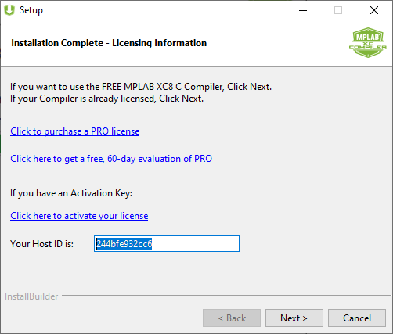

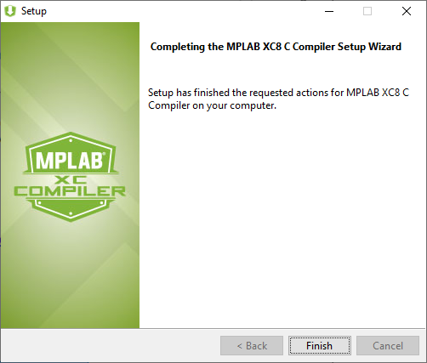

**Part2:**

1. Open the MPLAB X IDE:



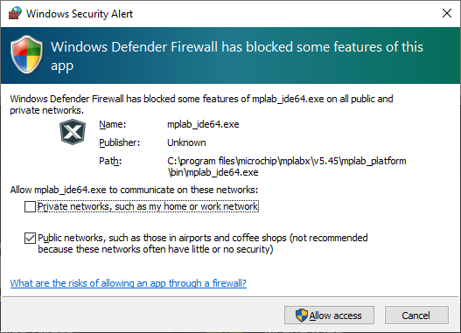

1. Click on **Create New Project**. Choose **Standalone Project**: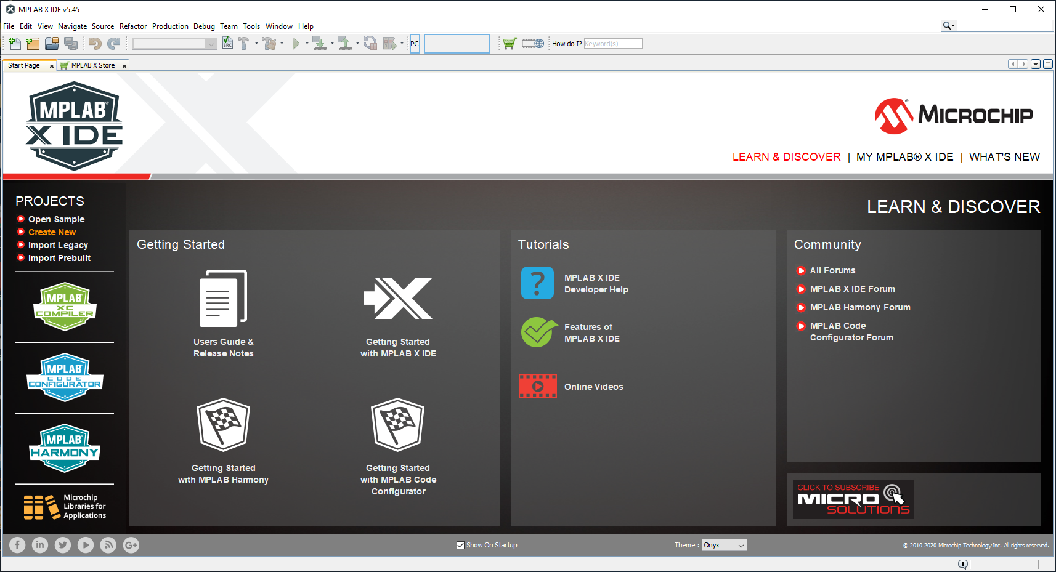

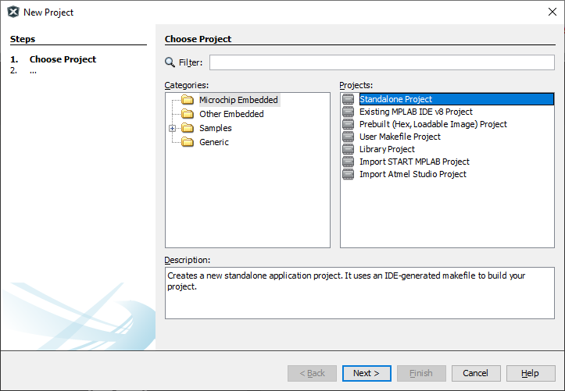

1. Select the device we have in the kit. First select the **Advanced 8-bit MCUs (PIC18)** to make it easier to find the correct chip and Select the **Simulator** as the tool: 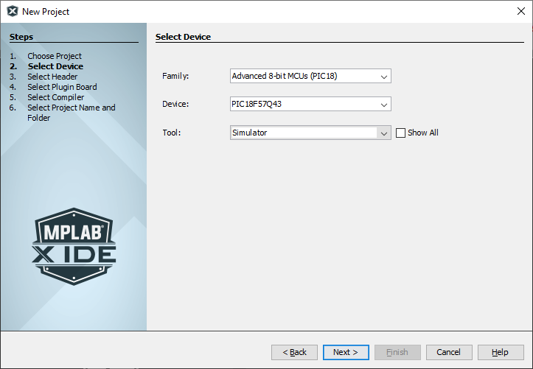
2. Select the pic-as assembler: 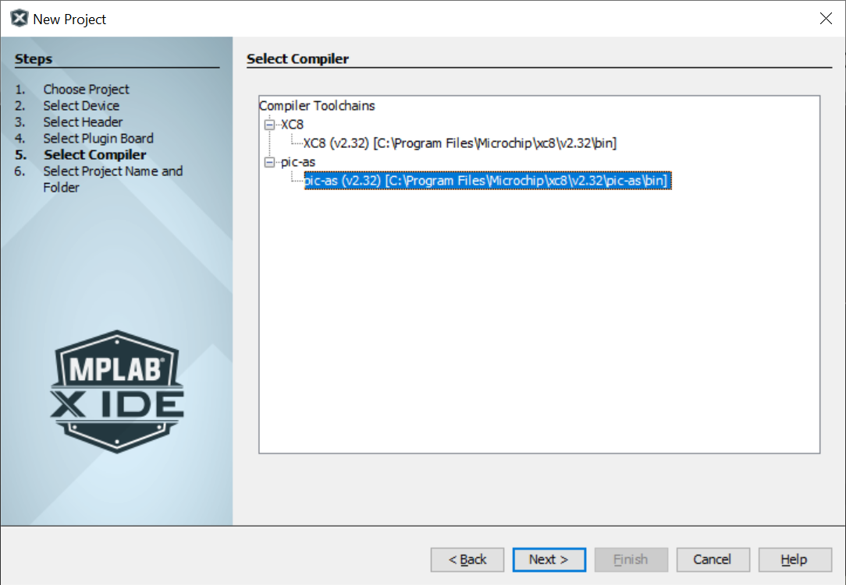
3. Enter a good project name. Use a name that tells what the program does: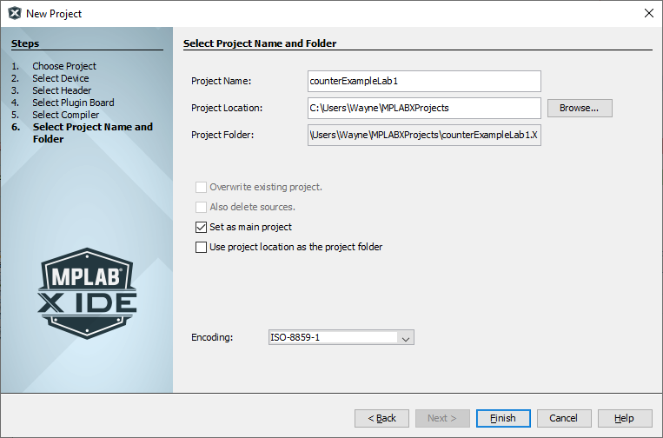
4. Right click on **Source Files**. Then highlight **New**, select **Other:** 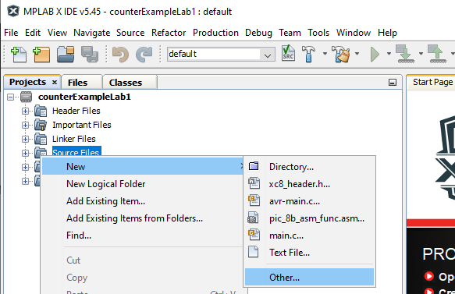
5. Choose the file type: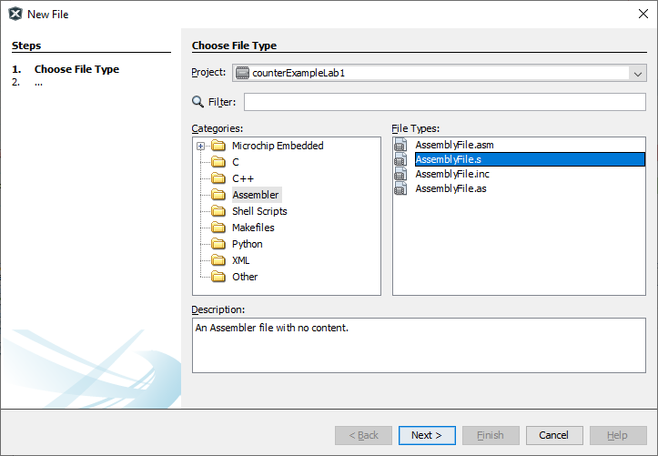
6. Enter the name of the assembly file: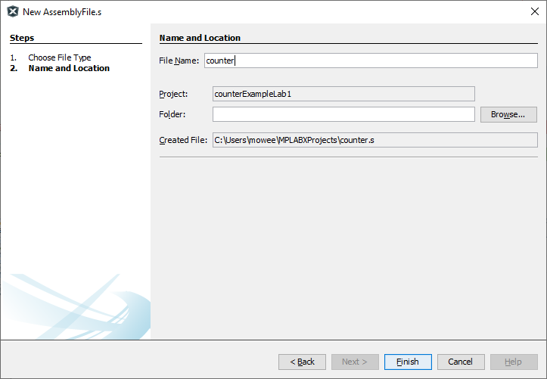
7. Your screen should look like this: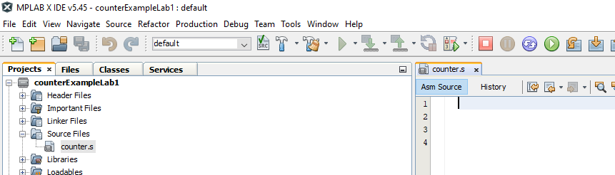
8. Type in the following code. Pay close attention to tabs and spacing: 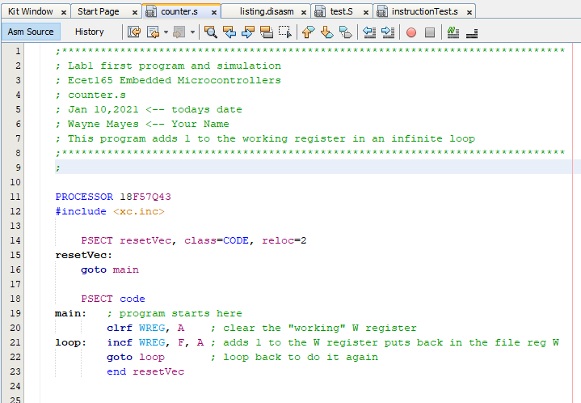
9. Save your code.
10. Build your project: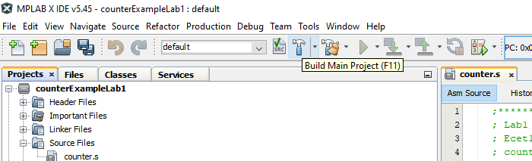

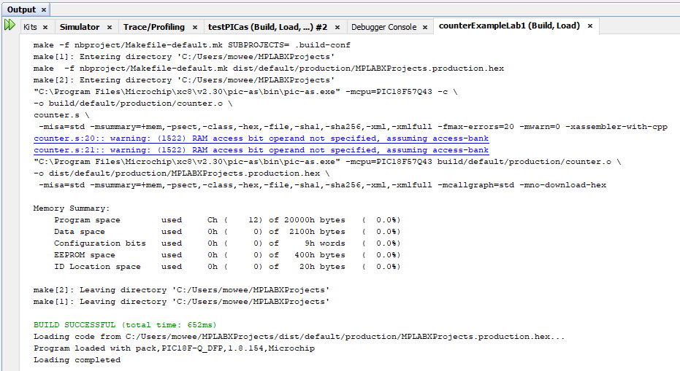

1. Take a look at Disassembly listing file: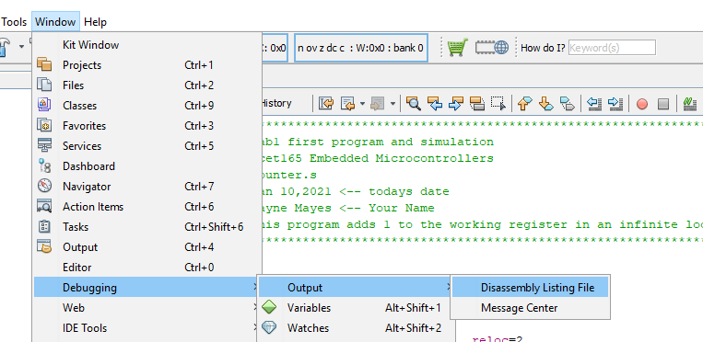
2. If you get this error, make sure you follow the instructions to build the symbol information: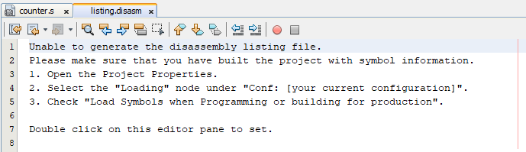
3. Select load symbols when programming: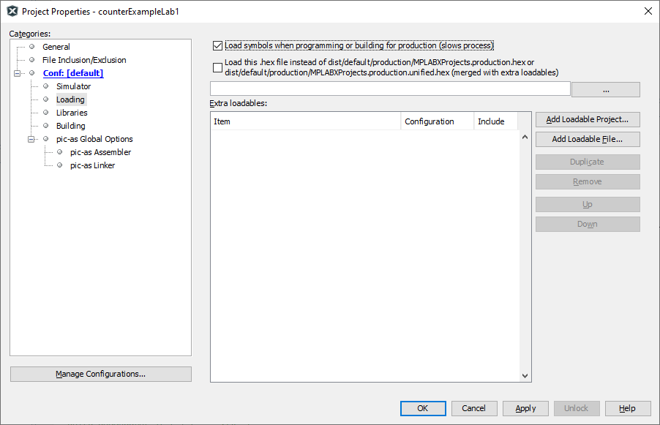
4. Build the main project: 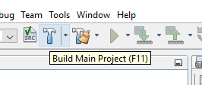
5. Now take a look at Disassembly listing file: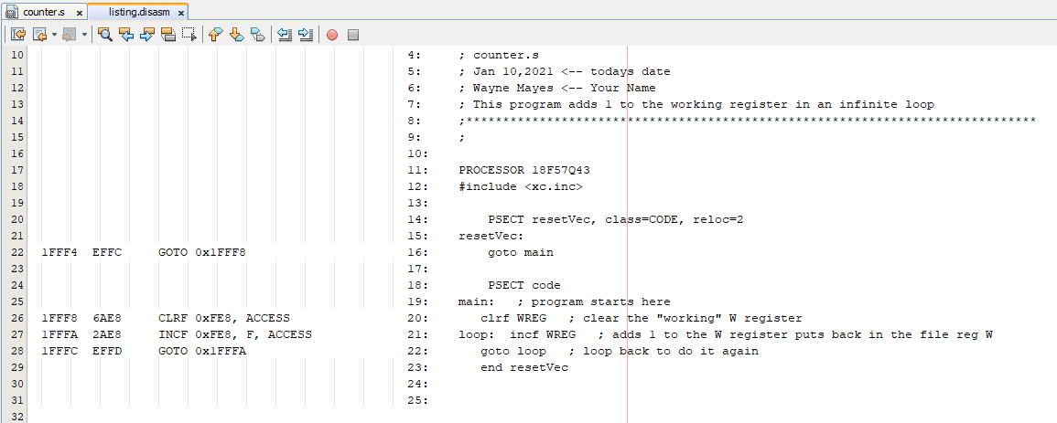
6. Debug the main project: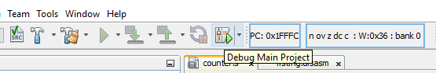
7. Now the program is running, but we cannot see the result: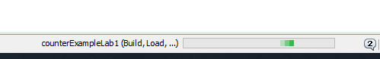
8. Pause the program: 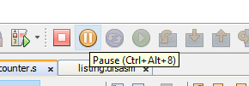
9. Right click to add a new watch variable: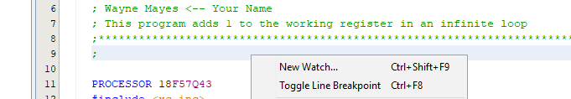
10. Type in the WREG and select SFR’s, or you can select from the SFR list: 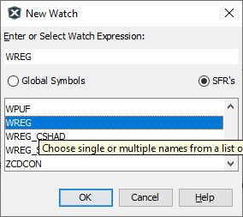
11. Mouse over each of the following buttons. Experiment with each of these buttons. Use google if necessary to help test and understand how each button works.



**Answer the following question in this word doc and upload to D2L.**

1. Research each of the following tools and explain their use in your own words?



Build the project file



Clean up previous builds and then build the project



Build and run project in debugger environments



Stop program running in debug environment



Reset program running in debugger



Resume program running in debugger



Execute next instruction



Step into subroutine



Run program from current spot to the cursor spot



Set program counter at cursor



Move the cursor to where the PC is



Indicates the current address of the PC



Specifies the address of the WREG and the current bank



Pauses the program running in the debugger



Program the device, read the program currently on the device, or force a full reconnect of the device, reset it, and hold it from running.